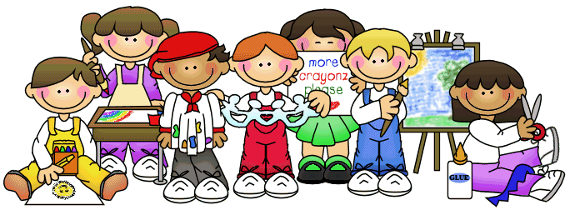

***First Grade Supply List***

* 1 large book bag (please, no wheeled ones because they do not fit in our cubbies) – big enough to hold a homework folder and projects
* Pair of headphones to keep at school (labeled)
* 2 boxes of Kleenex
* 1 package of glue sticks (skinny ones)
* 1 red and 1 blue folder
* 1 composition book
* 1 pack Clorox wipes
* 1 bottle hand sanitizer (Purell if possible)
* 1 box of **Crayola** crayons (No Crazy Art crayons please)
* 1 pair of kids scissors
* 1 plastic container pencil box
* A set of extra clothes in a zip lock bag, socks, underwear, shirt and pants
* A mask for each day and extras in backpack.

Thank you for your support.  We look forward to an exciting year of learning!  Please let us know if you have questions or concerns. ☺